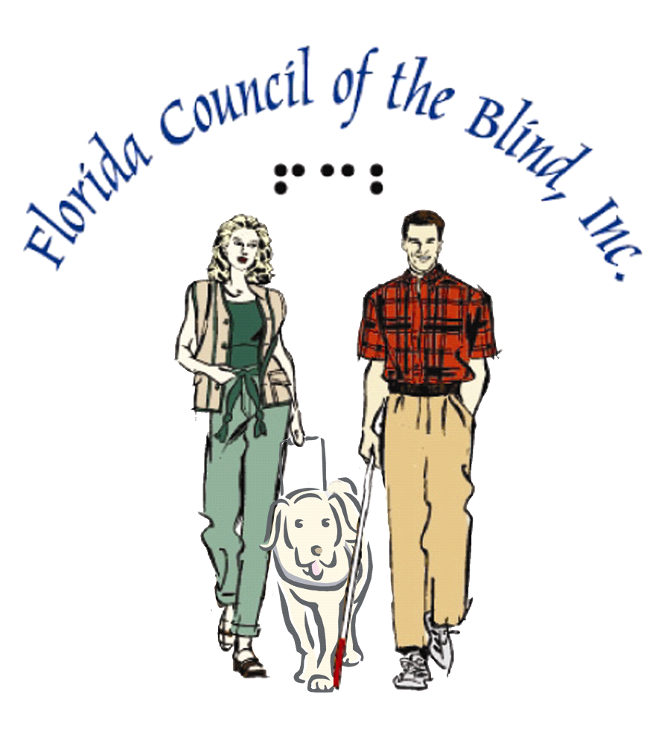

YOU HAVE LOST YOUR SIGHT

PROJECT INSIGHT

PROMOTING INDEPENDENCE FOR ALL PEOPLE WHO ARE VISUALLY IMPAIRED

If you are a Florida resident, who is visually impaired, and need help adjusting to your vision loss, call Project Insight today!

1-800-26SIGHT
1-800-267-4448

Our statewide network of trained, volunteer/advisors who are visually impaired themselves will assist with:
- Understanding, support and encouragement
- Referrals to local, state, and national organizations
- Information
- Help with achieving a positive attitude toward loss of sight

ALL CALLS ARE CONFIDENTIAL

